Project DesignPhase-I Solution Architecture

|  |  |
| --- | --- |
| Date | 18 October2022 |
| TeamID | PNT2022TMID23206 |
| ProjectName | VisualizingandPredictingHeart  DiseaseswithanInteractiveDashBoard |
| MaximumMarks | 4Marks |

**SolutionArchitecture:**

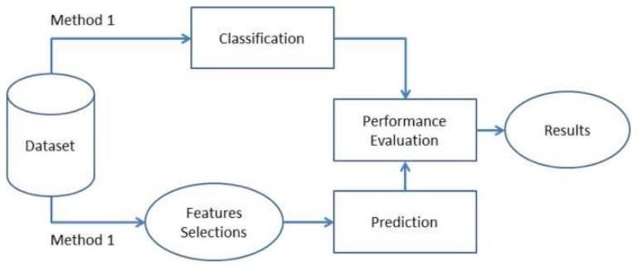

The leading cause of death in the developed world is heart disease. Therefore,there needs to be work done to help prevent the risks of having a heart attack orstroke. This dataset to predict which patients are most likely to suffer from aheart disease in the near future using the features given. Heart disease is one ofthe biggest causes of morbidity and mortality among the population of theworld. Prediction of cardiovascular disease is regarded as one of the mostimportantsubjects inthesectionofclinicaldataanalysis.Theamountofdata inthe healthcare industry is huge. Data mining turns the large collection of rawhealthcare data into information that can help to make informed decisions andpredictions.Thedatasetconsistsof303individuals’data.Thereare14columnsinthedataset,whicharedescribedbelow.

IMPORTDATASET

After downloading the dataset from Kaggle, we saved it to my workingdirectory with the name dataset.csv. Next, we used read_csv () to read thedatasetandsaveittothedatasetvariable.Beforeanyanalysis,Ijustwantedto

takealookatthedata. So, weusedtheinfo()method. Thereareatotalof13features and 1 target variable. Also, there are no missing values so we don’tneedtotakecare ofanynullvalues.Next,weusedtodescribe()method.

Parameters:

1.Age2.Sex

3.Chestpaintype4.BP

5.Cholesterol6.FBSover1207.EKG results8.MaxHR

9.Exercise angina10.ST depression11.SlopeofST

12.Number of vessels fluro13.Thallium

14.HeartDisease

**Age:**Ageisthemostimportantrisk factorindevelopingcardiovascularorheartdiseases,withapproximatelyatriplingofriskwitheachdecadeoflife.

Coronaryfattystreakscanbegintoforminadolescence. Itisestimatedthat82percentofpeoplewho dieofcoronaryheartdiseaseare65andolder.

Simultaneously,theriskofstrokedoubleseverydecadeafterage55.

**Sex:**Menareatgreaterriskofheartdiseasethanpre-menopausalwomen. Oncepast menopause, it has been argued that a woman’s risk is similar to a man’salthough more recent data from the WHO and UN disputes this. If a female hasdiabetes,sheismorelikelytodevelopheartdiseasethanamalewithdiabetes.

**Chest Pain:** Angina is chest pain or discomfort caused when your heart muscledoesn’t get enough oxygen-rich blood. It may feel like pressure or squeezing inyourchest.Thediscomfortalsocanoccurinyourshoulders, arms,neck, jaw,orback.Anginapainmayevenfeellikeindigestion.

**BloodPressure:**Overtime,highbloodpressurecandamagearteriesthat feedyour heart. High blood pressure that occurs with other conditions, such asobesity,highcholesterolordiabetes,increasesyourriskevenmore.

**Cholesterol:**Ahighleveloflow-densitylipoprotein(LDL)cholesterol(the“bad” cholesterol) is most likely to narrow arteries. A high level oftriglycerides, a type of blood fat related to your diet, also ups your risk of aheart attack. However, a high level of high-density lipoprotein (HDL)cholesterol(the“good”cholesterol)lowersyourriskofa heartattack.

**FastingBloodSugar:** Notproducingenoughofahormonesecretedbyyourpancreas (insulin) or not responding to insulin properly causes your body’sbloodsugar levelstorise,increasingyourrisk ofaheartattack.

**Resting ECG:** For people at low risk of cardiovascular disease, the USPSTFconcludes with moderate certainty that the potential harms of screening withresting or exercise ECG equal or exceed the potential benefits. For people atintermediatetohighrisk,currentevidence isinsufficienttoassessthebalanceofbenefitsandharmsofscreening.

**Max heart rate achieved:** The increase in cardiovascular risk, associated withthe acceleration of heart rate, was comparable to the increase in risk observedwithhighbloodpressure. Ithas beenshownthatanincreaseinheartrateby10beatsperminutewasassociated withanincreaseintheriskofcardiacdeathbyat least 20%, and this increase in the risk is similar to the one observed with anincreaseinsystolicbloodpressureby10mmHg.

**Exercise induced angina:** The pain or discomfort associated with anginausually feels tight, gripping or squeezing, and can vary from mild to severe.Angina is usually felt in the centre of your chest but may spread to either orbothofyourshoulders,oryourback,neck,jaworarm.Itcanevenbefeltinyourhands.TypesofAnginaa.Stable Angina/ AnginaPectorisb.UnstableAngina c.Variant(Prinzmetal)Anginad.MicrovascularAngina.

**Peak exercise ST segment:** A treadmill ECG stress test is considered abnormalwhen there is a horizontal or down-sloping ST-segment depression ≥ 1 mm at60–80msafterthe Jpoint. Exercise ECGswithup-slopingST-segmentdepressions are typically reported as an ‘equivocal’ test. In general, theoccurrence of horizontal or down-sloping ST-segment depression at a lowerworkload (calculated in METs) or heart rate indicates a worse prognosis andhigher likelihood of multi-vessel disease. The duration of ST-segmentdepression isalsoimportant,asprolonged recoveryafterpeakstressisconsistent with a positive treadmill ECG stress test. Another finding that ishighlyindicative of significant CAD is the occurrence of ST segment elevation

>1 mm(often suggesting transmuralischemia);these patients are frequently referred urgently for coronary angiography.

Patients from age 29 to 79 have been selected in this dataset. Male patients are denoted by a gender value 1 and female patients are denoted by gender value 0.Fourtypesofchestpaincanbeconsideredasindicativeofheartdisease.Type1anginais caused by reduced blood flow to the heart muscles because of narrowed coronary arteries. Type 1 Angina is a chest pain that occurs during mental or emotional stress. Non-angina chest pain may be caused due to various reasons and may not often be due to actual heart disease. The fourth type, Asymptomatic, may not be a symptom of heart disease. The next attribute trest bps is the reading of the resting blood pressure. Chol is the cholesterol level. Fbs is the fasting blood sugar level; the value is assigned as1ifthefastingbloodsugarisbelow 120 mg/dl and0ifitisabove.Restecg is the resting electrocardiographic result, thalach is the maximum heart rate, exang is the exercise induced angina which is recorded as 1 if there is pain and 0 if there is no pain, old peak is the ST depression induced by exercise, slope is the slope of the peak exercise ST segment, ca is the number of major vessels colored by fluoroscopy, thal is the duration of the exercise test in minutes, and num is the class attribute. The class attribute has a value of 0 for normal and 1 for patients diagnosed with heart disease.